Business Questions:
1. Where do profits come from?
Which products/ categories and Countries drive revenue vs. margin after accounting for returns/ cancellations?
Category: Lightning & Fixtures
Products: Stock Code M and 22423
Country: United Kingdom
2. Who are our best customers and How do we keep them?
Build RFM Segments (Recency-Frequency-Monetary) and derive actions (e.g. "win-back", "VIP nurture", "new growth")
Best Customer: Customer ID 18102
3. When do we sell the most and what should we stock?
Identify seasonality & trends in monthly revenue; quantify the impact of returns and large-order outliers. Use a simple baseline forecast to inform inventory planning.
Highest Daily Revenue: 01/03/2009
Highest Weekly Revenue: 03/01/2009
Highest Monthly Revenue: Mar 2009

Python Coding below:
import polars as pl
import pandas as pd
import matplotlib.pyplot as plt

df = pl.read_csv(
"online_retail_II.csv",
ignore_errors=True, # skip bad lines
infer_schema_length=0, # scan all rows for correct dtypes
low_memory=True, # chunked parsing
try_parse_dates=True # parsing dates
)
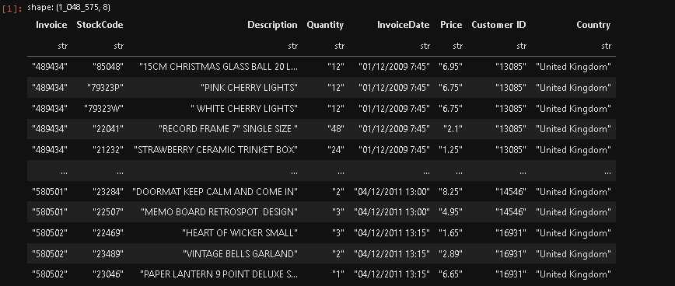
# Clean invoice date change from str to date only

# Parsing only Invoice Date column then reuse
df = df.with_columns([
pl.col("InvoiceDate")
.str.strptime(pl.Datetime, "%m/%d/%Y %H:%M", strict=False)
.alias("Invoice_DateTime")
])

df = df.with_columns([
pl.col("Invoice_DateTime").dt.date().alias("Invoice_Date"),
pl.col("Invoice_DateTime").dt.strftime("%b %Y").alias("Month-YYYY"), # MMM YYYY Format only
# pl.col("Invoice_DateTime").dt.strftime("%b").alias("Month"), # MMM Format only

# Parse as MM-01-YYYY → convert back to Date type properly
pl.col("Invoice_DateTime")
.dt.strftime("%m-01-%Y") # create string like "01-01-2011"
.str.strptime(pl.Date, "%m-%d-%Y", strict=False) # convert string to Date
.alias("Month-MM-dd-YYYY"),

pl.col("Invoice_DateTime")
.dt.truncate("1w") # start of the week (Monday)
.dt.date() # convert to date only
.alias("Week")
])

# Clean space description
df = df.with_columns([
pl.col("Description").str.strip_chars(" ,.;+").alias("Description") # removes spaces, commas, periods, semicolons, plus
])

# Define categorization function
def categorize(desc: str) -> str:
desc = str(desc).lower()
if "christmas" in desc or "xmas" in desc or "bells" in desc or "decoration" in desc:
return "Christmas Decorations"
elif "light" in desc or "lamp" in desc or "sign" in desc or "hook" in desc or "door" in desc or "storage" in desc \
or "kit" in desc or "box" in desc or "block" in desc or "set" in desc or "mat" in desc or "gardening" in desc \
or "metal" in desc or "frame" in desc or "stool" in desc or "stick" in desc or "wall" in desc:
return "Lighting & Fixtures"
elif "cup" in desc or "mug" in desc or "tea" in desc or "plate" in desc or "lunch" in desc or "cutlery" in desc \
or "bottle" in desc or "coaster" in desc or "pot" in desc or "ceramic" in desc or "glass" in desc or "goblet" in desc \
or "basket" in desc or "cases" in desc or "stand" in desc or "apron" in desc or "holder" in desc \
or "apron" in desc or "torch" in desc or "bowl" in desc or "straw" in desc or "jar" in desc:
return "Kitchenware"
elif "bag" in desc or "bracelet" in desc or "slides" in desc or "comb" in desc or "brooch" in desc or "pin" in desc \
or "ring" in desc or "patches" in desc or "sign" in desc or "hanger" in desc or "ornament" in desc or "knit" in desc \
or "umbrella" in desc or "earrings" in desc or "button" in desc or "muff" in desc or "key" in desc or "" in desc:
return "Bags & Accessories"
elif "card" in desc or "wrap" in desc or "toys" in desc or "sticker" in desc or "memo" in desc or "doll" in desc \
or "cover" in desc or "clip" in desc or "match" in desc or "marbles" in desc or "puzzles" in desc \
or "game" in desc or "box" in desc or "ribbons" in desc or "car" in desc or "notebook" in desc \
or "book" in desc or "tag" in desc:
return "Stationery & Gifts"
elif "toilet" in desc:
return "Toiletries"
else:
return "Other"

# Apply category mapping (vectorized via .map_elements)
df = df.with_columns([
pl.col("Description")
.map_elements(categorize, return_dtype=pl.Utf8)
.alias("Category")
])

# Clean and cast numeric columns before computation
df = df.with_columns([
pl.col("Quantity").cast(pl.Float64).alias("Quantity"),
pl.col("Price").cast(pl.Utf8).str.replace_all(",", "").cast(pl.Float64).alias("Price_Clean"),
])

# Compute Revenue and flag returns
df = df.with_columns([
(pl.col("Quantity") * pl.col("Price_Clean")).alias("Revenue"),
((pl.col("Invoice").cast(pl.Utf8).str.starts_with("C")) | (pl.col("Quantity") < 0))
.alias("IsReturn")
])

# checking if invoice is return
df = df.with_columns([
pl.when(pl.col("IsReturn")).then(0).otherwise(pl.col("Revenue")).alias("Net_Revenue"),
pl.when(pl.col("IsReturn")).then(pl.col("Revenue")).otherwise(0).alias("Returns"),
])
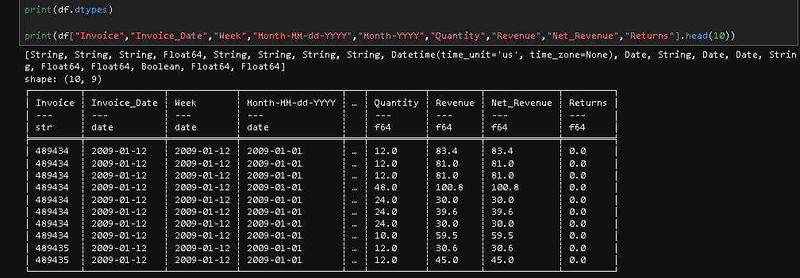
# Compute category summary
category_summary = (
df.group_by("Category")
.agg([
pl.sum("Revenue").alias("Gross_Revenue"),
pl.sum("Net_Revenue"),
pl.sum("Returns")
])
.sort("Net_Revenue", descending=True)
)

category_summary = category_summary.drop_nulls()

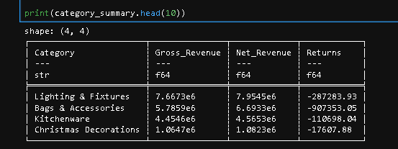
# Horizontal Bar Chart - Comparing Product Categories
# Convert Polars DataFrame to pandas manually
category_pd = pd.DataFrame(category_summary.to_dicts())

# Sort by Net_Revenue descending (highest first)
category_pd = category_pd.sort_values(by="Net_Revenue", ascending=True)

plt.figure(figsize=(12, 11)) # Reasonable figure size
plt.barh(category_pd["Category"], category_pd["Net_Revenue"], color='skyblue', label="Net Revenue")

# Adding Labels, title, and legend
plt.title("Product Categories - Net Revenue", fontsize=14)
plt.xlabel("Net Revenue", fontsize=12)
plt.ylabel("Category", fontsize=12)
plt.grid(axis="x", linestyle="--", alpha=0.5)

# Labels on bars
for i, v in enumerate(category_pd["Net_Revenue"]):
plt.text(v, i, f"{v:,.0f}", va="center", ha="left", fontsize=9, color="black")

plt.tight_layout()
plt.legend()

# Show the summary in table
print(category_summary.head(10))

# Show Chart
plt.show()
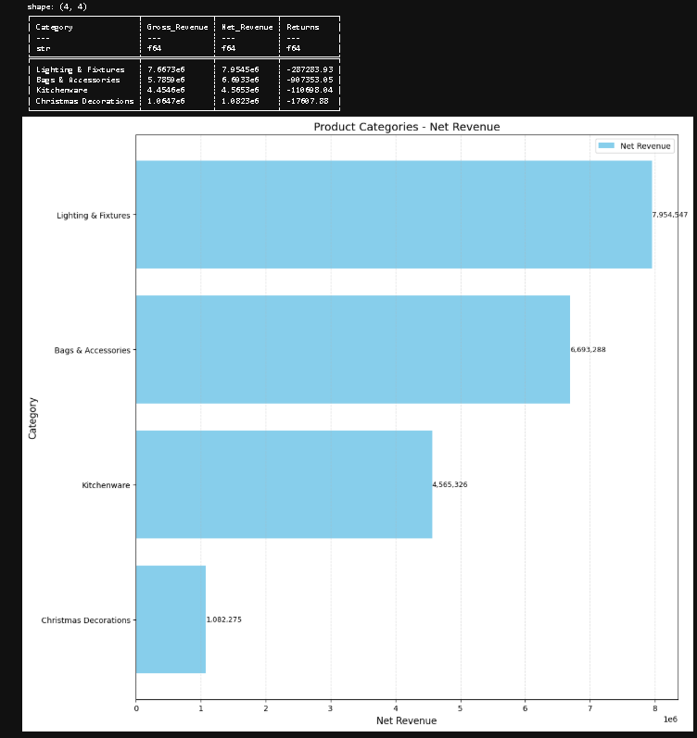
# Stock Code Summary
stock_code_summary = (
df.group_by("StockCode")
.agg([
pl.sum("Revenue").alias("Gross_Revenue"),
pl.sum("Net_Revenue"),
pl.sum("Returns")
])
.sort("Net_Revenue", descending=True)
)

stock_code_summary = stock_code_summary.drop_nulls()
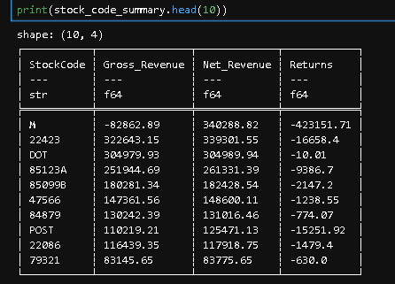
# Horizontal Bar Chart - Comparing Stock Code Categories

# Convert Polars DataFrame to pandas manually
stock_code_pd = pd.DataFrame(stock_code_summary.head(10).to_dicts())

# Sort by Net_Revenue descending (highest first)
stock_code_pd = stock_code_pd.sort_values(by="Net_Revenue", ascending=True)

plt.figure(figsize=(12, 11)) # Reasonable figure size
plt.barh(stock_code_pd["StockCode"], stock_code_pd["Net_Revenue"], color='gray', label="Net Revenue")

# Adding Labels, title, and legend
plt.title("Stock Codes - Net Revenue", fontsize=14)
plt.xlabel("Net Revenue", fontsize=12)
plt.ylabel("Stock Code ", fontsize=12)
plt.grid(axis="x", linestyle="--", alpha=0.5)

# Labels on bars
for i, v in enumerate(stock_code_pd["Net_Revenue"]):
plt.text(v, i, f"{v:,.0f}", va="center", ha="left", fontsize=9, color="black")

plt.tight_layout()
plt.legend()

# Show the table summary
print(stock_code_summary.head(10))

# Show Chart
plt.show()
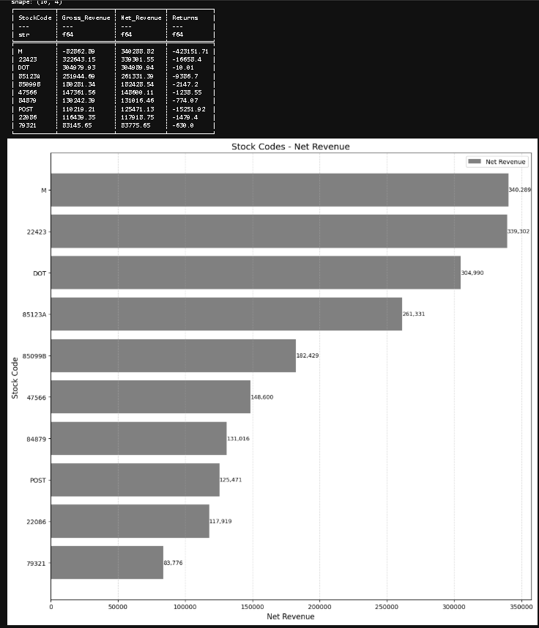
# Country Summary
country_summary = (
df.group_by("Country")
.agg([
pl.sum("Revenue").alias("Gross_Revenue"),
pl.sum("Net_Revenue"),
pl.sum("Returns")
])
.sort("Net_Revenue", descending=True)
)

country_summary = country_summary.drop_nulls()
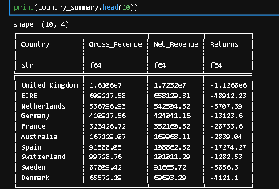
# Horizontal Bar Chart - Comparing Country Categories

# Convert Polars DataFrame to pandas manually
country_pd = pd.DataFrame(country_summary.to_dicts())

# Sort by Net_Revenue descending (highest first)
country_pd = country_pd.sort_values(by="Net_Revenue", ascending=True)

plt.figure(figsize=(12, 11)) # Reasonable figure size
plt.barh(country_pd["Country"], country_pd["Net_Revenue"], color='yellow', label="Net Revenue")

# Adding Labels, title, and legend
plt.title("Country - Net Revenue", fontsize=14)
plt.xlabel("Net Revenue", fontsize=12)
plt.ylabel("Country", fontsize=12)
plt.grid(axis="x", linestyle="--", alpha=0.5)

# Labels on bars
for i, v in enumerate(country_pd["Net_Revenue"]):
plt.text(v, i, f"{v:,.0f}", va="center", ha="left", fontsize=9, color="black")

plt.tight_layout()
plt.legend()

# Show Summary in table
print(country_summary.head(10))

# Show Chart
plt.show()
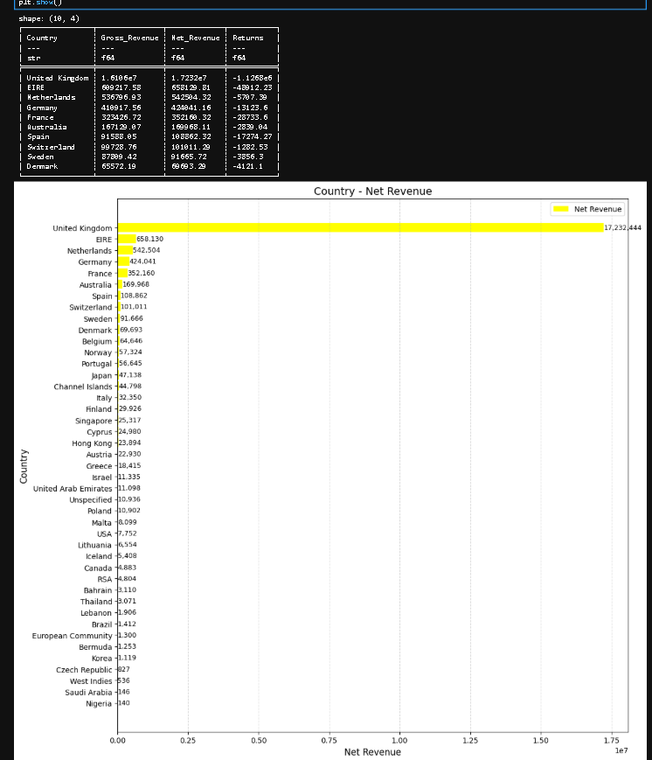
# Description Summary
description_summary = (
df.group_by("Description")
.agg([
pl.sum("Revenue").alias("Gross_Revenue"),
pl.sum("Net_Revenue"),
pl.sum("Returns")
])
.sort("Net_Revenue", descending=True)
)

description_summary = description_summary.drop_nulls()
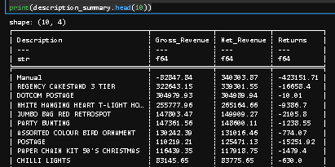
# Horizontal Bar Chart - Comparing Description Categories
# Convert Polars DataFrame to pandas manually
description_pd = pd.DataFrame(description_summary.head(10).to_dicts())

# Sort by Net_Revenue descending (highest first)
description_pd = description_pd.sort_values(by="Net_Revenue", ascending=True)

plt.figure(figsize=(12, 11)) # Reasonable figure size
plt.barh(description_pd["Description"], description_pd["Net_Revenue"], color='purple', label="Net Revenue")

# Adding Labels, title, and legend
plt.title("Description - Net Revenue", fontsize=14)
plt.xlabel("Net Revenue", fontsize=12)
plt.ylabel("Description", fontsize=12)
plt.grid(axis="x", linestyle="--", alpha=0.5)

# Labels on bars
for i, v in enumerate(description_pd["Net_Revenue"]):
plt.text(v, i, f"{v:,.0f}", va="center", ha="left", fontsize=9, color="black")

plt.tight_layout()
plt.legend()

# Show Summary in Table
print(description_summary.head(10))

# Show Chart
plt.show()
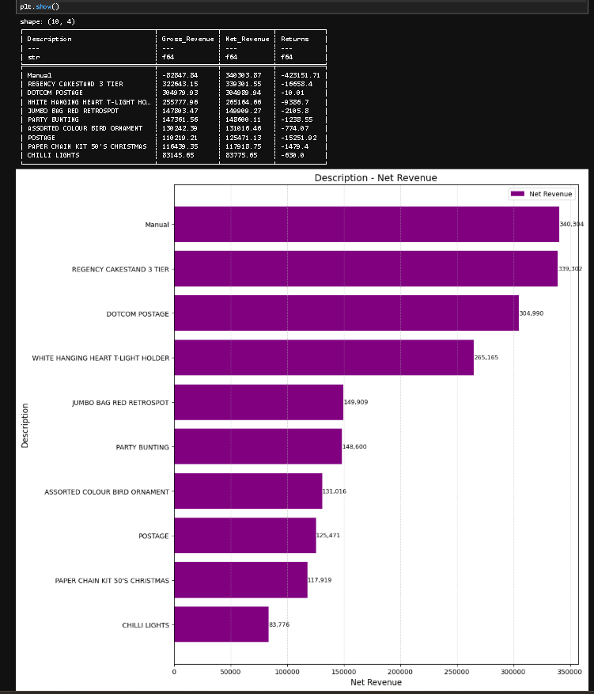
# Customer Summary
customer_summary = (
df.group_by("Customer ID")
.agg([
pl.sum("Revenue").alias("Gross_Revenue"),
pl.sum("Net_Revenue"),
pl.sum("Returns")
])
.sort("Net_Revenue", descending=True)
)

customer_summary = customer_summary.drop_nulls()
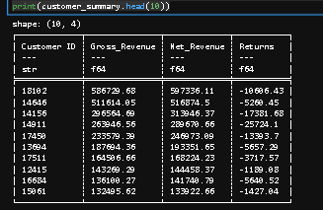
# Horizontal Bar Chart - Comparing Customer Categories

# Convert Polars DataFrame to pandas manually
customer_pd = pd.DataFrame(customer_summary.head(10).to_dicts())

# Sort by Net_Revenue descending (highest first)
customer_pd = customer_pd.sort_values(by="Net_Revenue", ascending=True)

plt.figure(figsize=(12, 11)) # Reasonable figure size
plt.barh(customer_pd["Customer ID"], customer_pd["Net_Revenue"], color='orange', label="Net Revenue")

# Adding Labels, title, and legend
plt.title("Customer ID - Net Revenue", fontsize=14)
plt.xlabel("Net Revenue", fontsize=12)
plt.ylabel("Customer ID", fontsize=12)
plt.grid(axis="x", linestyle="--", alpha=0.5)

# Labels on bars
for i, v in enumerate(customer_pd["Net_Revenue"]):
plt.text(v, i, f"{v:,.0f}", va="center", ha="left", fontsize=9, color="black")

plt.tight_layout()
plt.legend()

# Show Summary in Table
print(customer_summary.head(10))

# Show Chart
plt.show()
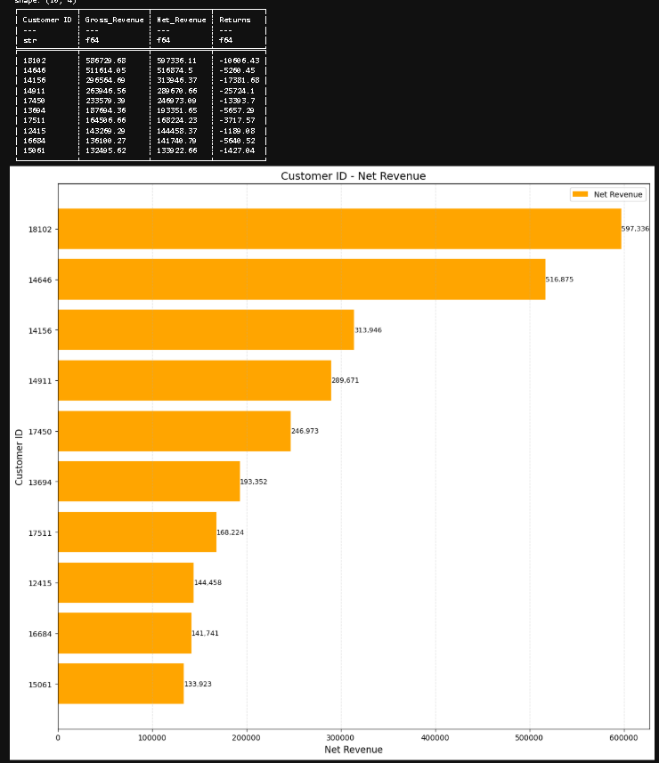
# Daily Summary
daily_summary = (
df.group_by("Invoice_Date")
.agg([
pl.sum("Revenue").round(2).alias("Gross_Revenue"),
pl.sum("Net_Revenue").round(2),
pl.sum("Returns").round(2)
])
.with_columns([
pl.col("Invoice_Date")
.dt.strftime("%m-%d-%Y") # format as MM-dd-yyyy
.str.strptime(pl.Date, "%m-%d-%Y", strict=False) # convert back to Date type
.alias("Invoice_Date")
])
.sort("Invoice_Date", descending=False)
)

daily_summary = daily_summary.drop_nulls()
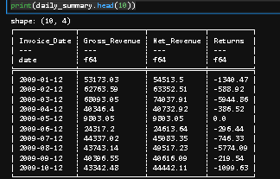
# Line Graph for Daily Net Revenue

import matplotlib.pyplot as plt
import pandas as pd
from matplotlib.dates import DateFormatter

# Convert Polars DataFrame to pandas manually
daily_pd = pd.DataFrame(daily_summary.head(10).to_dicts())

# Parse 'Invoice_Date' as datetime
daily_pd["Invoice_Date"] = pd.to_datetime(daily_pd["Invoice_Date"], format="%m-%d-%Y", errors="coerce")

# Drop nulls if any failed to parse
daily_pd = daily_pd.dropna(subset=["Invoice_Date"])

# Sort by actual datetime
daily_pd = daily_pd.sort_values(by="Invoice_Date", ascending=True)

# --- Plot ---
fig, ax = plt.subplots(figsize=(12,11))
ax.plot(daily_pd["Invoice_Date"], daily_pd["Net_Revenue"], marker='o', color='steelblue')

# Add labels on each point
ymin, ymax = ax.get_ylim()
yoff = 0.02 * (ymax-ymin)

for x,y in zip(daily_pd["Invoice_Date"], daily_pd["Net_Revenue"]):
ax.text(x,y + yoff, f"${y:,}", ha="center", va="bottom", fontsize=9)

# Title and labels
ax.set_title("Daily Net Revenue")
ax.set_xlabel("Date")
ax.set_ylabel("Net Revenue")

# Format x-axis date as MM-dd-YYYY
date_format = DateFormatter("%m-%d-%Y")
ax.xaxis.set_major_formatter(date_format)
fig.autofmt_xdate(rotation=45) # rotate labels for readability

# Grid and layout
ax.grid(True, linestyle="--", alpha=0.5)
plt.tight_layout()

# Show Summary in table
print(daily_summary.head(10)) # polars dataFrame
print(daily_pd.head(10)) # pandas dataFrame

plt.show()
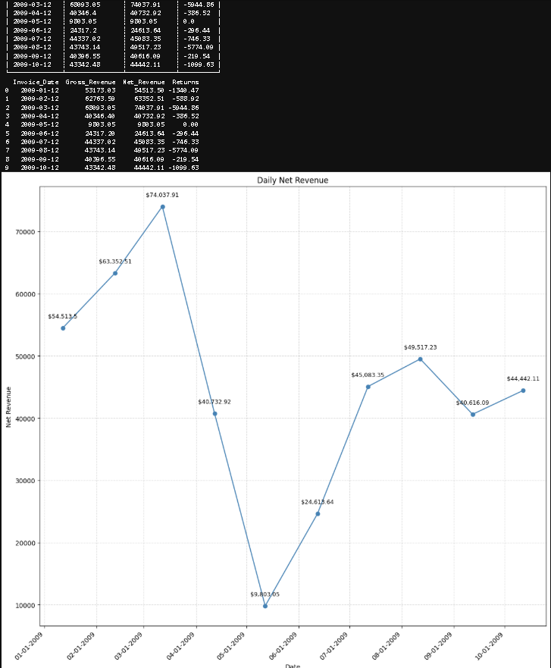

# Weekly Summary

# Weekly Summary
weekly_summary = (
df.group_by("Week")
.agg([
pl.sum("Revenue").round(2).alias("Gross_Revenue"),
pl.sum("Net_Revenue").round(2),
pl.sum("Returns").round(2)
])
.with_columns([
pl.col("Week")
.dt.strftime("%m-%d-%Y") # format as MM-dd-yyyy
.str.strptime(pl.Date, "%m-%d-%Y", strict=False) # convert back to Date type
.alias("Invoice_Date")
])
.sort("Week", descending=False)
)
weekly_summary = weekly_summary.drop_nulls()
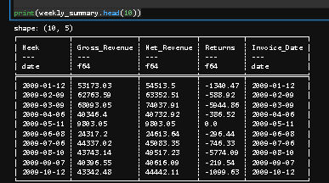
# Line Graph for Weekly Net Revenue

import matplotlib.pyplot as plt
import pandas as pd
from matplotlib.dates import DateFormatter

# Convert Polars DataFrame to pandas manually
weekly_pd = pd.DataFrame(weekly_summary.head(10).to_dicts())

# Parse 'Invoice_Date' as datetime
weekly_pd["Week"] = pd.to_datetime(weekly_pd["Week"], format="%m-%d-%Y", errors="coerce")

# Drop nulls if any failed to parse
weekly_pd = weekly_pd.dropna(subset=["Week"])

# Sort by actual datetime
weekly_pd = weekly_pd.sort_values(by="Week", ascending=True)

# --- Plot ---
fig, ax = plt.subplots(figsize=(12,11))
ax.plot(weekly_pd["Week"], weekly_pd["Net_Revenue"], marker='o', color='steelblue')

# Add labels on each point
ymin, ymax = ax.get_ylim()
yoff = 0.02 * (ymax-ymin)

for x,y in zip(weekly_pd["Week"], weekly_pd["Net_Revenue"]):
ax.text(x,y + yoff, f"${y:,}", ha="center", va="bottom", fontsize=9)

# Title and labels
ax.set_title("Weekly Net Revenue")
ax.set_xlabel("Week")
ax.set_ylabel("Net Revenue")

# Format x-axis date as MM-dd-YYYY
date_format = DateFormatter("%m-%d-%Y")
ax.xaxis.set_major_formatter(date_format)
fig.autofmt_xdate(rotation=45) # rotate labels for readability

# Grid and layout
ax.grid(True, linestyle="--", alpha=0.5)
plt.tight_layout()

# Show Summary in table
print(weekly_summary.head(10)) # polars dataFrame
print(weekly_pd.head(10)) # pandas dataFrame

plt.show()
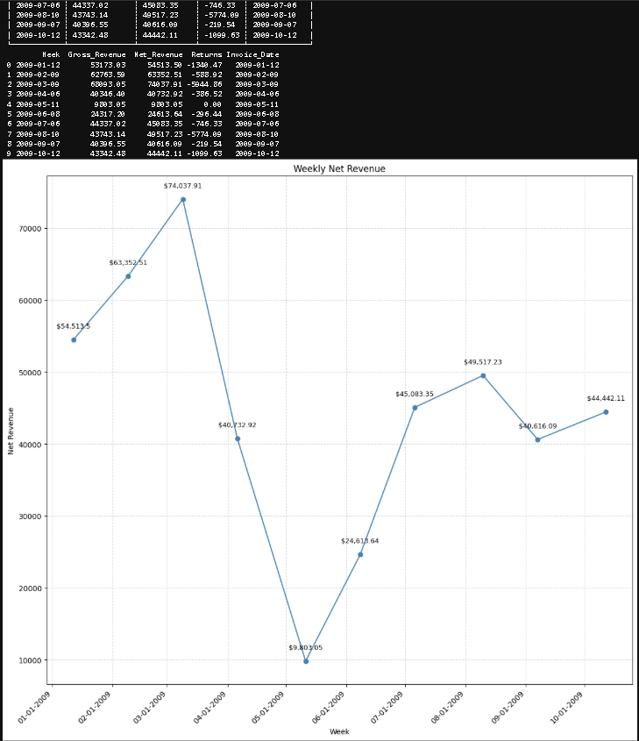

# Monthly Summary
monthly_summary = (
df.group_by(["Month-YYYY", "Month-MM-dd-YYYY"])
.agg([
pl.sum("Revenue").alias("Gross_Revenue"),
pl.sum("Net_Revenue").round(2),
pl.sum("Returns").round(2)
])
.sort("Month-MM-dd-YYYY", descending=False) # sort by actual date
)

# Drop nulls for safety
monthly_summary = monthly_summary.drop_nulls()
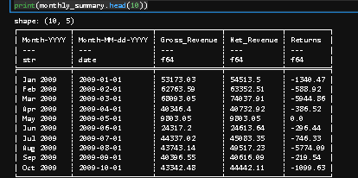
# Line Graph for Monthly Net Revenue

import matplotlib.pyplot as plt
import pandas as pd
from matplotlib.dates import DateFormatter

# Convert Polars DataFrame to pandas manually
monthly_pd = pd.DataFrame(monthly_summary.head(10).to_dicts())

# Ensure Month-MM-dd-YYYY is a datetime for sorting and plotting
monthly_pd["Month-MM-dd-YYYY"] = pd.to_datetime(monthly_pd["Month-MM-dd-YYYY"], errors="coerce")

# Sort chronologically (ascending)
monthly_pd = monthly_pd.sort_values(by="Month-MM-dd-YYYY", ascending=True)

# --- Line Graph for Monthly Net Revenue ---
fig, ax = plt.subplots(figsize=(12,11))
ax.plot(monthly_pd["Month-YYYY"], monthly_pd["Net_Revenue"], marker='o', color='steelblue')

# Add labels above points
ymin, ymax = ax.get_ylim()
yoff = 0.02 * (ymax-ymin)
for x, y in zip(monthly_pd["Month-YYYY"], monthly_pd["Net_Revenue"]):
ax.text(x, y + yoff, f"${y:,.0f}", ha="center", va="bottom", fontsize=9)

# Title, labels, grid
ax.set_title("Monthly Net Revenue")
ax.set_xlabel("Month")
ax.set_ylabel("Net Revenue")
ax.grid(True, linestyle="--", alpha=0.5)
plt.tight_layout()

print(monthly_summary.head(10))
print(monthly_pd.head(10))

plt.show()
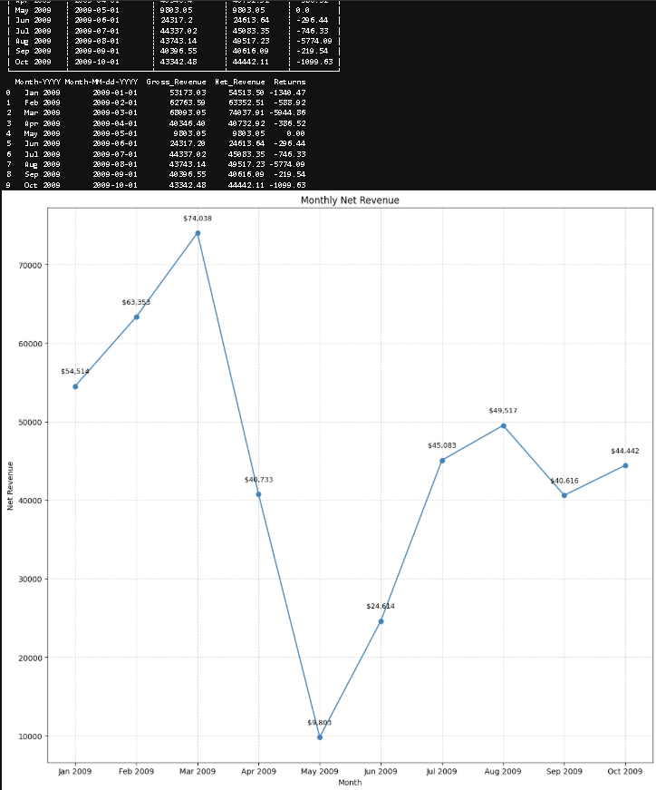
# Filter only valid (non-return) transactions
df_valid = df.filter(~pl.col("IsReturn"))

# Building Recency-Frequency-Monetary segments
# Define reference date (max invoice date + 1 day)
max_date = df_valid["Invoice_Date"].max()
reference_date = max_date + pl.duration(days=1)

# Compute RFM metrics
rfm = (
df_valid.group_by("Customer ID")
.agg([
# Recency: days since last purchase
(reference_date - pl.col("Invoice_Date").max())
.dt.total_days()
.alias("Recency"),

# Frequency: number of invoices
pl.col("InvoiceDate").count().alias("Frequency"),

# Monetary: total revenue
pl.col("Revenue").sum().alias("Monetary")
])
.sort("Monetary", descending=True)
)

print(rfm.columns)
print(rfm.head(10))
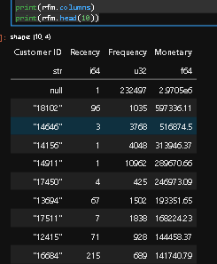
# Compute quantile thresholds
q = rfm.select([
pl.col("Recency").quantile(0.2).alias("R_20"),
pl.col("Recency").quantile(0.4).alias("R_40"),
pl.col("Recency").quantile(0.6).alias("R_60"),
pl.col("Recency").quantile(0.8).alias("R_80"),
pl.col("Frequency").quantile(0.2).alias("F_20"),
pl.col("Frequency").quantile(0.4).alias("F_40"),
pl.col("Frequency").quantile(0.6).alias("F_60"),
pl.col("Frequency").quantile(0.8).alias("F_80"),
pl.col("Monetary").quantile(0.2).alias("M_20"),
pl.col("Monetary").quantile(0.4).alias("M_40"),
pl.col("Monetary").quantile(0.6).alias("M_60"),
pl.col("Monetary").quantile(0.8).alias("M_80"),
]).to_dict(as_series=False)
rfm = rfm.with_columns([
# Recency (lower is better)
pl.when(pl.col("Recency") <= q["R_20"][0]).then(5)
.when(pl.col("Recency") <= q["R_40"][0]).then(4)
.when(pl.col("Recency") <= q["R_60"][0]).then(3)
.when(pl.col("Recency") <= q["R_80"][0]).then(2)
.otherwise(1).alias("R_Score"),

# Frequency (higher is better)
pl.when(pl.col("Frequency") <= q["F_20"][0]).then(1)
.when(pl.col("Frequency") <= q["F_40"][0]).then(2)
.when(pl.col("Frequency") <= q["F_60"][0]).then(3)
.when(pl.col("Frequency") <= q["F_80"][0]).then(4)
.otherwise(5).alias("F_Score"),

# Monetary (higher is better)
pl.when(pl.col("Monetary") <= q["M_20"][0]).then(1)
.when(pl.col("Monetary") <= q["M_40"][0]).then(2)
.when(pl.col("Monetary") <= q["M_60"][0]).then(3)
.when(pl.col("Monetary") <= q["M_80"][0]).then(4)
.otherwise(5).alias("M_Score"),
])

print(rfm.columns)
print(rfm.head(10))
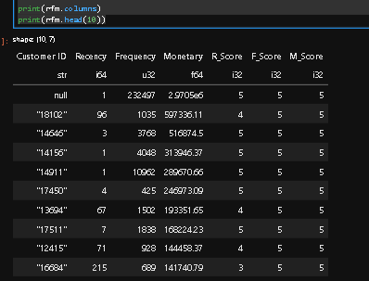
# Define customer segments
rfm = rfm.with_columns(
pl.when(pl.col("RFM_Score") >= 13).then(pl.lit("Champions"))
.when(pl.col("RFM_Score") >= 10).then(pl.lit("Loyal Customers"))
.when(pl.col("RFM_Score") >= 7).then(pl.lit("Potential Loyalist"))
.when(pl.col("RFM_Score") >= 4).then(pl.lit("At Risk"))
.otherwise(pl.lit("Lost"))
.alias("Segment")
)
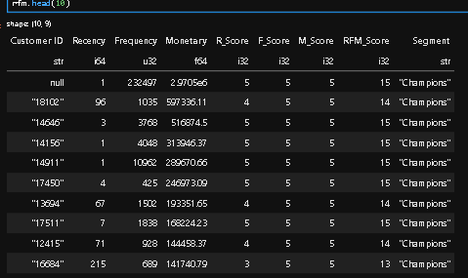
# sort RFM via customers
rfm = (
rfm.group_by("Segment")
.agg([
pl.count().alias("Customers"),
pl.col("Monetary").mean().alias("Avg_Monetary")
])
.sort("Customers", descending=True)
)
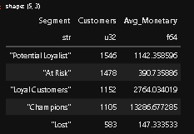
# Bar Chart - Comparing RFM via Customers

import polars as pl
import pandas as pd
import matplotlib.pyplot as plt

# Convert Polars DataFrame to pandas manually
rfm_pd = pd.DataFrame(rfm.head(10).to_dicts())

# Create combined label for X-axis
rfm_pd["Segment_Customers"] = rfm_pd["Segment"] + " (" + rfm_pd["Customers"].astype(str) + ")"

# Sort by Avg_Monetary descending for better visualization
rfm_pd = rfm_pd.sort_values(by="Avg_Monetary", ascending=False)

# Plot Vertical Bar Chart
plt.figure(figsize=(10, 6))
bars = plt.bar(rfm_pd["Segment_Customers"], rfm_pd["Avg_Monetary"], color='orange', label="Avg Monetary")

# Add Titles and Labels
plt.title("RFM Segments by Average Monetary Value", fontsize=14, weight='bold')
plt.xlabel("Segment | Customer ID", fontsize=12)
plt.ylabel("Average Monetary Value", fontsize=12)
plt.grid(axis="y", linestyle="--", alpha=0.5)

# Add value labels above each bar
for bar in bars:
height = bar.get_height()
plt.text(bar.get_x() + bar.get_width()/2, height + (height*0.02),
f"{height:,.0f}", ha="center", va="bottom", fontsize=9, color="black")

# Rotate x labels for readability
plt.xticks(rotation=45, ha="right")

plt.tight_layout()
plt.legend()

# Show Summary in Table
print(rfm_pd.head(10)) # Pandas DataFrame
print(rfm.head(10)) # Polars DataFrame

# Show Chart
plt.show()
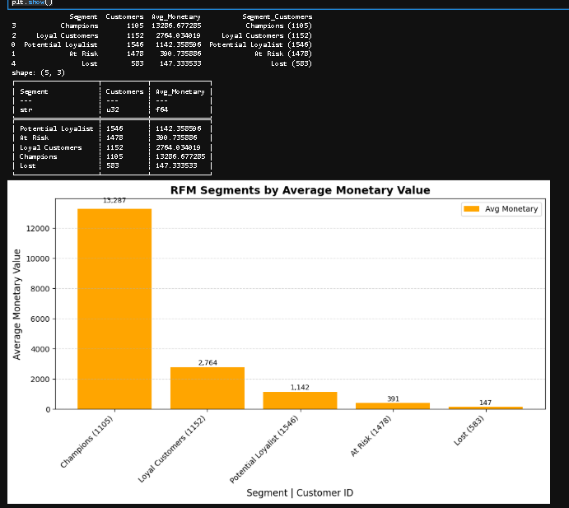
# detects large-order outliers (IQR method and top-percentile method) and measures their share of units/revenue
import polars as pl
import math

# Example defaults for inventory calc
lead_time_weeks = 2.0 # lead time in weeks (tunable)
service_z = 1.645 # z-value for ~95% service level (tunable)
forecast_weeks = 4 # used only if you implement rolling mean later (we use avg_weekly baseline)
outlier_pct = 0.99 # top percentile threshold for outlier detection (alternative method)
iqr_multiplier = 1.5 # IQR multiplier for classical outlier detection

# Ensure Invoice_Date exists (date)
if "Invoice_Date" not in df.columns and "Invoice_DateTime" in df.columns:
df = df.with_columns(pl.col("Invoice_DateTime").dt.date().alias("Invoice_Date"))

# Filter only non-null Invoice_Date for time aggregations
df = df.filter(pl.col("Invoice_Date").is_not_null())

# Convert Quantity to numeric (use absolute for units sold accounting)
df = df.with_columns(pl.col("Quantity").cast(pl.Float64).alias("Quantity"))

print(df.head(10))
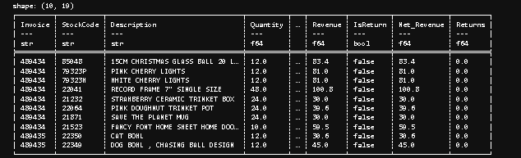
# Quantify returns impact

# Per product (StockCode) compute sold units, returned units, gross revenue, revenue lost to returns
product_returns = (
df.group_by("StockCode")
.agg([
# Get the first description for each product
pl.col("Description").first().alias("Description"),

# --- Compute Sold & Returned Units ---
pl.when(pl.col("IsReturn") == False)
.then(pl.col("Quantity"))
.otherwise(0)
.sum()
.alias("Units_Sold"),

pl.when(pl.col("IsReturn") == True)
.then(pl.col("Quantity"))
.otherwise(0)
.sum()
.alias("Units_Returned"),

# --- Compute Revenues ---
pl.when(pl.col("IsReturn") == False)
.then(pl.col("Revenue"))
.otherwise(0)
.sum()
.alias("Gross_Revenue"),

pl.when(pl.col("IsReturn") == True)
.then(pl.col("Revenue"))
.otherwise(0)
.sum()
.alias("Revenue_Returns"),
])
# --- Derived Metrics ---
.with_columns([
(pl.col("Units_Returned") /
(pl.col("Units_Sold") + pl.col("Units_Returned")))
.fill_null(0)
.alias("Return_Rate_Units"),

(pl.col("Revenue_Returns") /
(pl.col("Gross_Revenue") + pl.col("Revenue_Returns")))
.fill_null(0)
.alias("Return_Rate_Value"),

(pl.col("Gross_Revenue") - pl.col("Revenue_Returns"))
.alias("Net_Revenue"),
])
.sort("Revenue_Returns", descending=False)
)

# remove null values
product_returns = product_returns.drop_nulls()

# Top products by revenue lost to returns
top_products_return_impact = product_returns.head(10)

print(top_products_return_impact.head(10))
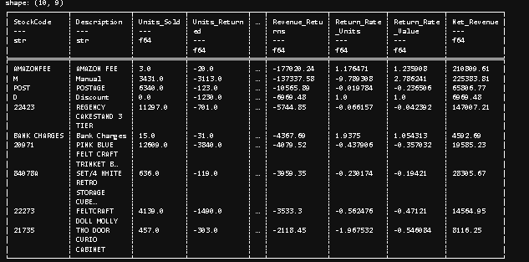
# Summarize at category level for Revenue Returns
if "Category" in df.columns:
category_returns = (
df.group_by("Category")
.agg([
# --- Units Sold ---
pl.when(pl.col("IsReturn") == False)
.then(pl.col("Quantity"))
.otherwise(0)
.sum()
.alias("Units_Sold"),

# --- Units Returned ---
pl.when(pl.col("IsReturn") == True)
.then(pl.col("Quantity"))
.otherwise(0)
.sum()
.alias("Units_Returned"),

# --- Gross Revenue (all sales, positive only) ---
pl.when(pl.col("IsReturn") == False)
.then(pl.col("Revenue"))
.otherwise(0)
.sum()
.alias("Gross_Revenue"),

# --- Revenue Lost to Returns ---
pl.when(pl.col("IsReturn") == True)
.then(pl.col("Revenue"))
.otherwise(0)
.sum()
.alias("Revenue_Returns"),
])
.with_columns([
# --- Derived Ratios ---
(pl.col("Revenue_Returns") / pl.col("Gross_Revenue"))
.fill_null(0)
.alias("Return_Rate_Value"),

(pl.col("Units_Returned") /
(pl.col("Units_Sold") + pl.col("Units_Returned")))
.fill_null(0)
.alias("Return_Rate_Units"),

(pl.col("Gross_Revenue") - pl.col("Revenue_Returns"))
.alias("Net_Revenue"),
])
.sort("Revenue_Returns", descending=False)
)
else:
category_returns = None

# remove null values
category_returns = category_returns.drop_nulls()

print(category_returns.head(10))
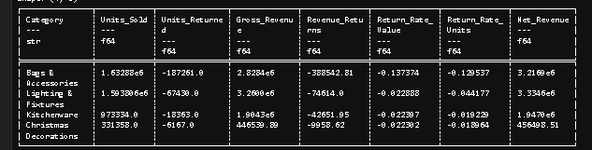
# Summarize at country level for Revenue Return

if "Country" in df.columns:
country_returns = (
df.group_by("Country")
.agg([
# --- Units Sold (non-return transactions) ---
pl.when(pl.col("IsReturn") == False)
.then(pl.col("Quantity"))
.otherwise(0)
.sum()
.alias("Units_Sold"),

# --- Units Returned ---
pl.when(pl.col("IsReturn") == True)
.then(pl.col("Quantity"))
.otherwise(0)
.sum()
.alias("Units_Returned"),

# --- Gross Revenue (sales only) ---
pl.when(pl.col("IsReturn") == False)
.then(pl.col("Revenue"))
.otherwise(0)
.sum()
.alias("Gross_Revenue"),

# --- Revenue Lost to Returns ---
pl.when(pl.col("IsReturn") == True)
.then(pl.col("Revenue"))
.otherwise(0)
.sum()
.alias("Revenue_Returns"),
])
.with_columns([
# --- Return Value Rate (% of revenue lost) ---
(pl.col("Revenue_Returns") / pl.col("Gross_Revenue"))
.fill_null(0)
.alias("Return_Rate_Value"),

# --- Return Unit Rate (% of units returned) ---
(pl.col("Units_Returned") /
(pl.col("Units_Sold") + pl.col("Units_Returned")))
.fill_null(0)
.alias("Return_Rate_Units"),

# --- Net Revenue after returns ---
(pl.col("Gross_Revenue") - pl.col("Revenue_Returns"))
.alias("Net_Revenue"),
])
.sort("Revenue_Returns", descending=False)
)
else:
country_returns = None

# remove null values
country_returns = country_returns.drop_nulls()

print(country_returns.head(10))
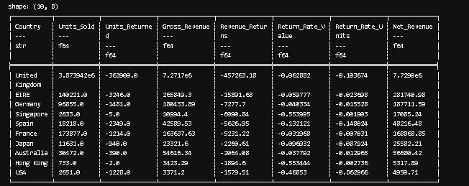
# Detect large-order outliers and quantify their impact

# Creating per-order (invoice x stockcode) order quantities and revenue (exclude returns)
orders = (
df.filter(~pl.col("IsReturn"))
.group_by(["Invoice", "StockCode"])
.agg([
pl.first("Invoice_Date").alias("Invoice_Date"),
pl.first("Country").alias("Country"),
pl.first("Description").alias("Description"),
pl.sum("Quantity").alias("Order_Quantity"),
pl.sum("Revenue").alias("Order_Revenue")
])
)

orders = orders.drop_nulls()

print(orders.head(10))
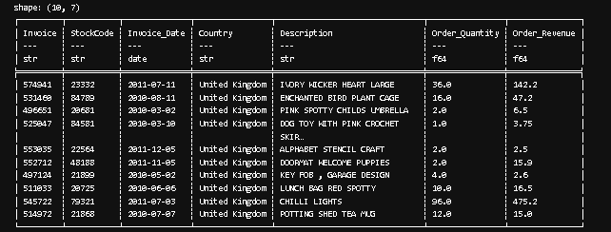
# For each StockCode compute distribution stats (Q1, Q3, IQR) to detect IQR outliers

source_df = df # replace with the real variable holding StockCode data

iqr_multiplier = 1.5

# Compute per-product statistics
stock_stats = (
source_df.group_by("StockCode")
.agg([
pl.col("Quantity").quantile(0.25).alias("Q1"),
pl.col("Quantity").quantile(0.75).alias("Q3"),
pl.col("Quantity").mean().alias("Mean_Qty"),
pl.col("Revenue").sum().alias("Total_Revenue"),
pl.len().alias("Num_Orders"),
])
.with_columns([
(pl.col("Q3") - pl.col("Q1")).alias("IQR"),
(pl.col("Q3") + (pl.col("Q3") - pl.col("Q1")) * iqr_multiplier).alias("IQR_Upper"),
])
.drop_nulls()
)

print(stock_stats.head(10))
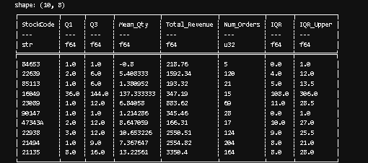
# Join orders with stock_stats to flag IQR outliers
orders_with_stats = orders.join(stock_stats.select(["StockCode", "IQR_Upper", "Mean_Qty"]), on="StockCode", how="left")
orders_with_stats = orders_with_stats.with_columns(
(pl.col("Order_Quantity") > pl.col("IQR_Upper")).alias("Is_IQR_Outlier")
)

print(orders_with_stats.head(10))
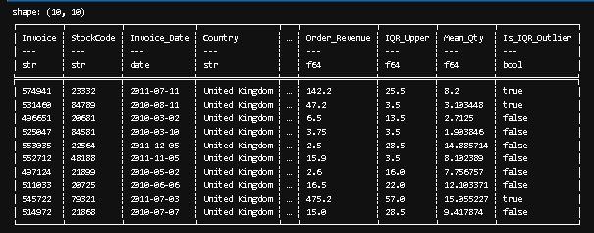
# Flag top percentile outliers (e.g. top 1%)
qty_thresholds = (
orders.group_by("StockCode")
.agg(pl.col("Order_Quantity").quantile(outlier_pct).alias("Top_Pct_Thresh"))
)

orders_with_stats = orders_with_stats.join(qty_thresholds, on="StockCode", how="left")
orders_with_stats = orders_with_stats.with_columns(
(pl.col("Order_Quantity") >= pl.col("Top_Pct_Thresh")).alias("Is_TopPct_Outlier")
)

orders_with_stats.sort("Top_Pct_Thresh", descending=False)
qty_thresholds.sort("Top_Pct_Thresh", descending=False)

print(orders_with_stats.head(10))
print(qty_thresholds.head(10))
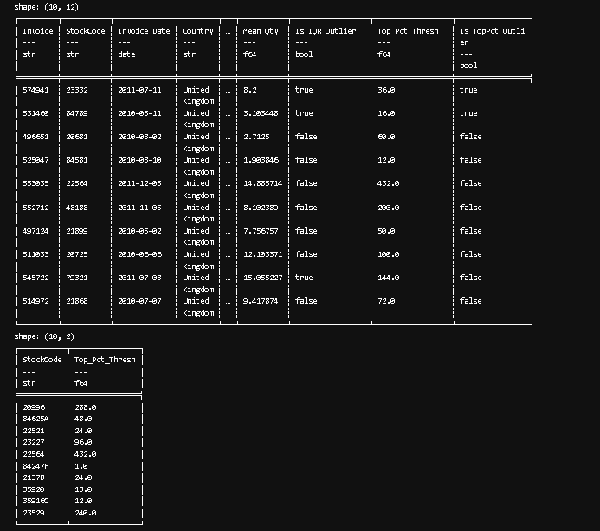
# Quantify impact of outliers at product level (share of units and revenue)

print(orders_with_stats.columns)

outlier_impact_by_stock = (
orders_with_stats.group_by("StockCode")
.agg([
pl.col("Order_Quantity").sum().alias("Total_Units"),
pl.col("Order_Revenue").sum().alias("Total_Revenue"),

# Compute outlier totals directly via .sum() on the expression
(
pl.when(pl.col("Is_IQR_Outlier") | pl.col("Is_TopPct_Outlier"))
.then(pl.col("Order_Quantity"))
.otherwise(0)
.sum()
.alias("Outlier_Units")
),
(
pl.when(pl.col("Is_IQR_Outlier") | pl.col("Is_TopPct_Outlier"))
.then(pl.col("Order_Revenue"))
.otherwise(0)
.sum()
.alias("Outlier_Revenue")
),
pl.col("Description").first().alias("Description"),
])
.with_columns([
(pl.col("Outlier_Units") / pl.col("Total_Units"))
.fill_null(0)
.alias("Outlier_Units_Share"),
(pl.col("Outlier_Revenue") / pl.col("Total_Revenue"))
.fill_null(0)
.alias("Outlier_Revenue_Share"),
])
.sort("Outlier_Revenue", descending=True)
)

print(orders_with_stats.head(10))
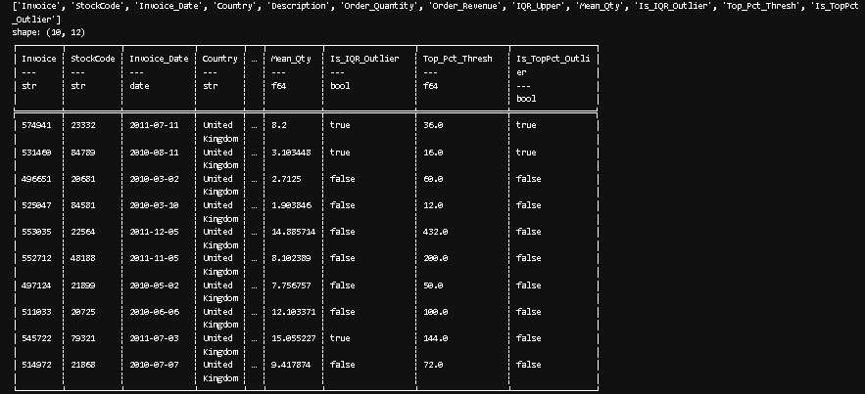
# Simple baseline forecast for inventory planning
# Using average weekly demand per StockCode as baseline forecast.
# Then compute a simple safety stock = z * std_weekly * sqrt(lead_time_weeks)
# Reorder recommendation = forecast_for_one_week * lead_time_weeks + safety_stock

lead_time_weeks = 2.0 # lead time in weeks (tunable)

# Use the Week column (week start Monday)
df_sales = df.filter(~pl.col("IsReturn")).select(["StockCode", "Invoice_Date", "Quantity"])
df_sales = df_sales.with_columns(pl.col("Invoice_Date").alias("Date"))
df_sales = df_sales.with_columns(
(pl.col("Invoice_Date").cast(pl.Datetime).dt.truncate("1w")).dt.date().alias("Week_Start")
)

weekly = (
df_sales.group_by(["StockCode", "Week_Start"])
.agg(pl.sum("Quantity").alias("Units"))
.sort(["StockCode", "Week_Start"])
)

print(weekly.head(10))
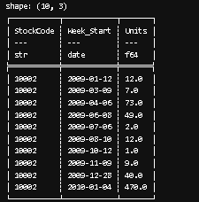
# per-stock weekly stats (mean & std)
weekly_stats = (
weekly.group_by("StockCode")
.agg([
pl.col("Units").mean().alias("Avg_Weekly_Units"),
pl.col("Units").std().fill_null(0).alias("Std_Weekly_Units"),
pl.count().alias("Weeks_Observed")
])
)

print(weekly_stats.head(10))
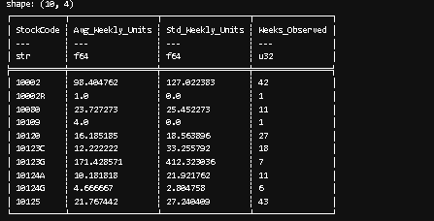
# Merge stats back to compute safety stock and recommended reorder
forecast_df = weekly_stats.with_columns([
# forecast for next week (baseline = average weekly)
pl.col("Avg_Weekly_Units").alias("Forecast_1wk"),
# safety stock scaled by sqrt(lead time in weeks)
(pl.col("Std_Weekly_Units") * pl.lit(service_z) * pl.lit(math.sqrt(lead_time_weeks))).alias("Safety_Stock"),
# reorder = forecast*lead_time + safety stock
(pl.col("Avg_Weekly_Units") * pl.lit(lead_time_weeks) + (pl.col("Std_Weekly_Units") * pl.lit(service_z) * pl.lit(math.sqrt(lead_time_weeks)))).round(0).alias("Reorder_Qty")
])

print(forecast_df.head(10))
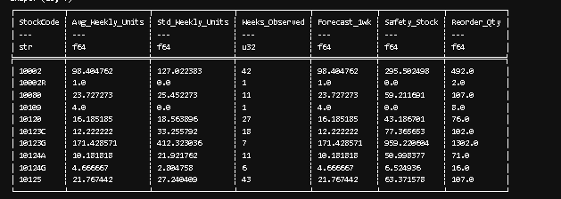
# Add product description and some current returns stats for context
# Join reorder with product_returns for context
forecast_df = forecast_df.join(
product_returns.select(["StockCode", "Units_Sold", "Units_Returned", "Return_Rate_Units", "Net_Revenue"]),
on="StockCode",
how="left"
).select([
"StockCode", "Avg_Weekly_Units", "Std_Weekly_Units", "Weeks_Observed",
"Forecast_1wk", "Safety_Stock", "Reorder_Qty", "Units_Sold", "Units_Returned", "Return_Rate_Units", "Net_Revenue"
]).sort("Reorder_Qty", descending=True)

print(forecast_df.head(10))
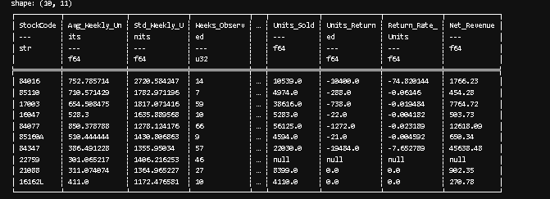
# Export to Excel

print(product_returns)
print(outlier_impact_by_stock)
print(forecast_df)

# product_returns.write_csv("product_returns_summary.csv")
# outlier_impact_by_stock.write_csv("outlier_impact_by_stock.csv")
# forecast_df.write_csv("reorder_recommendations.csv")
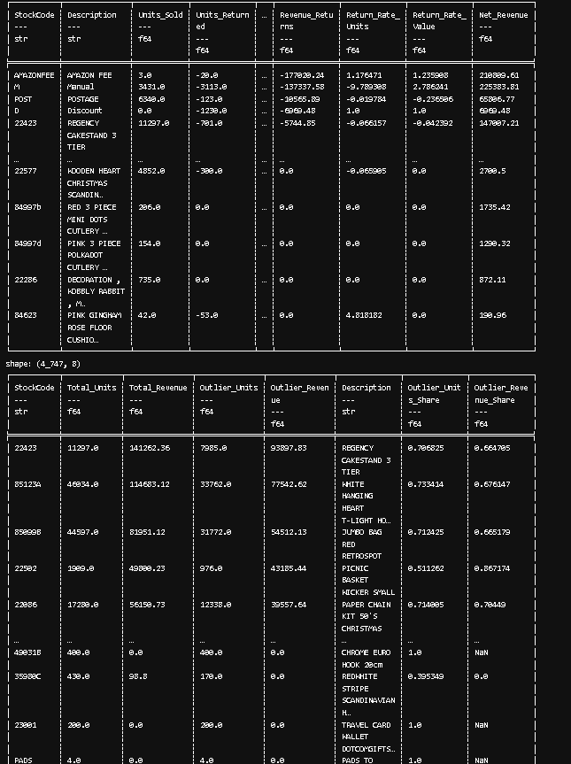
# Compute Average Order Value (AOV) per region, then run a two-sample t-test (UK vs Non-UK).
# Polars handles aggregation; SciPy handles the statistical test.
import polars as pl
from scipy.stats import ttest_ind

# Define region classification (U.K vs Non-U.K) = Data Cleaning to add Region
orders_with_region = df.with_columns([
pl.when(pl.col("Country") == "United Kingdom")
.then(pl.lit("UK")) # use pl.lit() for string literals as row value in each column
.otherwise(pl.lit("Non-UK"))
.alias("Region")
])

print(orders_with_region.columns)
print(orders_with_region.select(["Invoice","StockCode","Quantity","Country","Region"]).head(10))
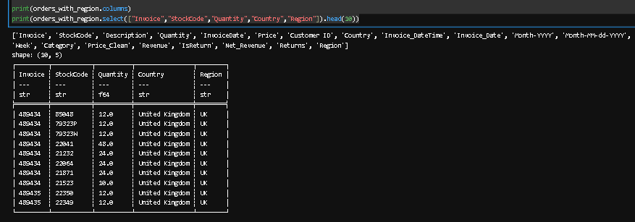
# Compute Revenue per row (if not yet computed)
if "Revenue" not in orders_with_region.columns:
orders_with_region = orders_with_region.with_columns((pl.col("Quantity") * pl.col("Price")).alias("Revenue"))

print(orders_with_region.select(["Invoice","StockCode","Quantity","Price","Revenue","Country","Region"]).head(10))
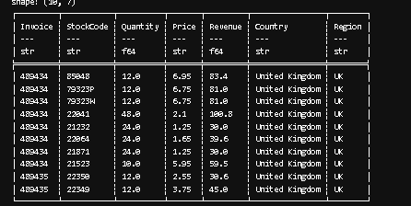
# Compute average order value per Country (total revenue / total quantity)
country_aov = (
orders_with_region.group_by(["Country", "Region"])
.agg([
pl.sum("Revenue").alias("Total_Revenue"),
pl.sum("Quantity").alias("Total_Units")
])
.with_columns([
(pl.col("Total_Revenue") / pl.col("Total_Units"))
.alias("Avg_Order_Value")
])
.drop_nulls()
)

print(country_aov.head(10))
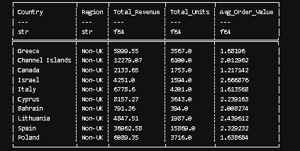
# Extract UK and Non-UK average order value arrays
import polars as pl
import numpy as np
from scipy.stats import ttest_ind

# Extract UK and Non-UK AOV arrays and clean NaN/infinite values
uk_aov = (
country_aov
.filter(pl.col("Region") == "UK")
.select("Avg_Order_Value")
.drop_nulls()
.to_series()
.to_numpy()
)

uk_aov = uk_aov[np.isfinite(uk_aov)] # remove inf/nan

non_uk_aov = (
country_aov
.filter(pl.col("Region") == "Non-UK")
.select("Avg_Order_Value")
.drop_nulls()
.to_series()
.to_numpy()
)

non_uk_aov = non_uk_aov[np.isfinite(non_uk_aov)] # remove inf/nan

# Extract top 10 Average Order Values for UK and Non-UK before converting to NumPy
uk_aov_top10 = (
country_aov.filter(pl.col("Region") == "UK")
.select(["Country", "Region", "Avg_Order_Value"])
.head(10)
)

non_uk_aov_top10 = (
country_aov.filter(pl.col("Region") == "Non-UK")
.select(["Country", "Region", "Avg_Order_Value"])
.head(10)
)

print(uk_aov_top10)
print(non_uk_aov_top10)

print(f"Sample Size for UK Region {len(uk_aov):.2f}")
print(f"Sample Size for Non-UK Region {len(non_uk_aov):.2f}")
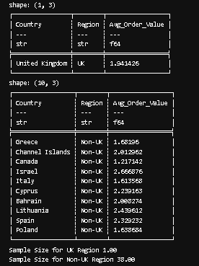
# Perform Two-Sample T-Test
# t_stat, p_value = ttest_ind(uk_aov, non_uk_aov, equal_var=False, nan_policy="omit")
# Check for valid sample sizes before performing t-test
if len(uk_aov) > 1 and len(non_uk_aov) > 1:
t_stat, p_value = ttest_ind(uk_aov, non_uk_aov, equal_var=False)
else:
t_stat, p_value = np.nan, np.nan
print("Not enough valid data points for t-test.")

print(f"T-statistic: {t_stat:.4f}")
print(f"P-value: {p_value:.6f}")
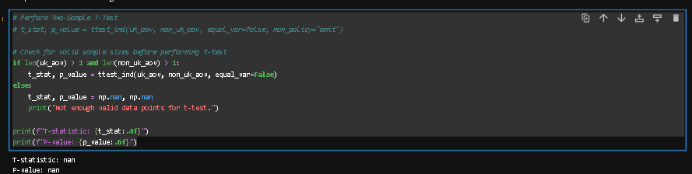
# Summarize results grouped by Region and Country
summary = (
country_aov
.group_by(["Country", "Region"])
.agg([
pl.mean("Avg_Order_Value").alias("Mean_AOV"),
pl.len().alias("Num_Invoices")
])
.sort("Country", "Region")
)

summary = summary.drop_nulls()

print("Average Order Value by Country and Region")
print(summary)
print("\nTwo-Sample T-Test Results (UK vs Non-UK)")
print(f"T-statistic: {t_stat:.4f}")
print(f"P-value: {p_value:.4f}")
